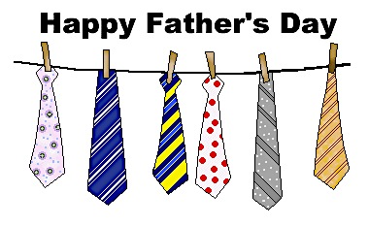

WELCOME TO THE BLACK OLIVE RESTAURANT FATHER’S DAY DINNER SPECIALS

DESSERT OF THE DAY:

**.……………….$5.99**

**CHEESECAKE WITH FRUIT TOPPING………..$4.99**

SOUP OF THE DAY APPETIZER OF THE DAY

***CHICKEN PASTINA FRIED CALAMARI………….$9.99***

***SEAFOOD BISQUE CHICKEN AND SPINACH QUESADILLA...$8.99***

1. T- BONE STEAK...........................…………..……………..….......$25.99

TOPPED WITH FRIED ONIONS, SERVED WITH A LOADED BAKED POTATO (WITH BROCCOLI, BACON, AND CHEDDAR CHEESE)

1. FATHER’S DAY SEAFOOD SCAMPI…………………...………$25.99

SHRIMP, SCALLOPS, CRABMEAT, LITTLE NECK CLAMS, AND BROCCOLI FLORETS IN A GARLIC LEMOM SCAMPI SAUCE SERVED OVER LINGUINE

1. PASTA BELLA LUNA……………..…...……………………....... $19.99

PENNE, GNOCCHI, CHEESE RAVIOLI AND CHEESE MANICOTTI IN A CRABMEAT BLUSH SAUCE

1. MARYLAND STUFFED SALMON FISH..…...............……....…$22.99

STUFFED WITH CRABMEAT AND PETITE SHRIMP SERVED WITH TWO VEGETABLES

1. CHICKEN SALTIMBOCCA……...……………………...……….$17.99

SAUTEED CHICKEN BREAST, MUSHROOMS, BABY LEAF SPINACH, IN A MARSALA WINE SAUCE, TOPPED WITH MELTED MOZZARELLA CHEESE, SERVED OVER PENNE

1. BBQ BROILED SHRIMP.……………………..…...……….…….$19.99

JUMBO SHRIMP (8), SERVED WITH TWO VEGETABLES

1. LAMB CHOPS……………………..…...……………………....... $20.99

TOPPED WITH BERMUDA FRIED ONIONS SERVED WITH GARLIC MASHED POTATOES AND ONE VEGETABLE

VEGETABLES OF THE DAY

MASHED POTATO, BAKED POTATO, FRENCH FRIES, COLE SLAW, APPLE SAUCE, COTTAGE CHEESE, PICKLED BEETS, STEAMED RICE, POTATO SALAD, FRIED

ZUCCHINI STICKS, OR ASPARAGUS

THANK YOU FOR DINING WITH US